Filed by Lamar Advertising Company

Pursuant to Rule 425 under the Securities Act of 1933

and deemed filed pursuant to Rule 14a-12

under the Securities and Exchange Act of 1934, as amended

Subject Company: Lamar Advertising Company

Commission File No. 000-30242

The following are copies of slides that Lamar Advertising Company intends to use in meetings with investors beginning on June 3, 2014.

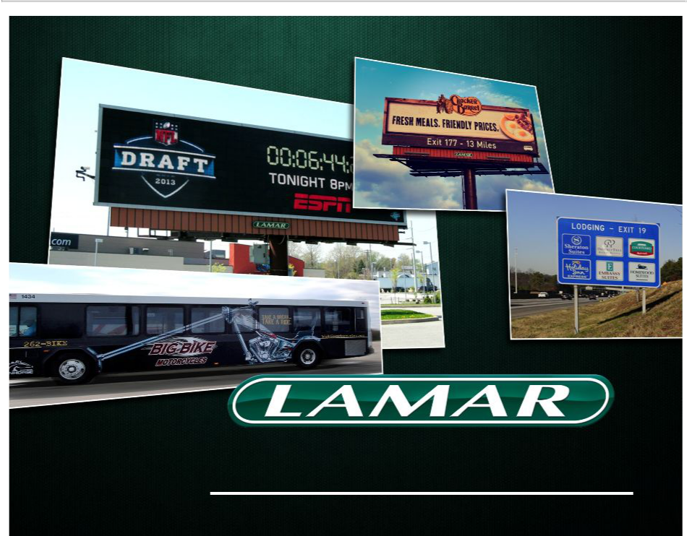
June 2014

INVESTOR PRESENTATION

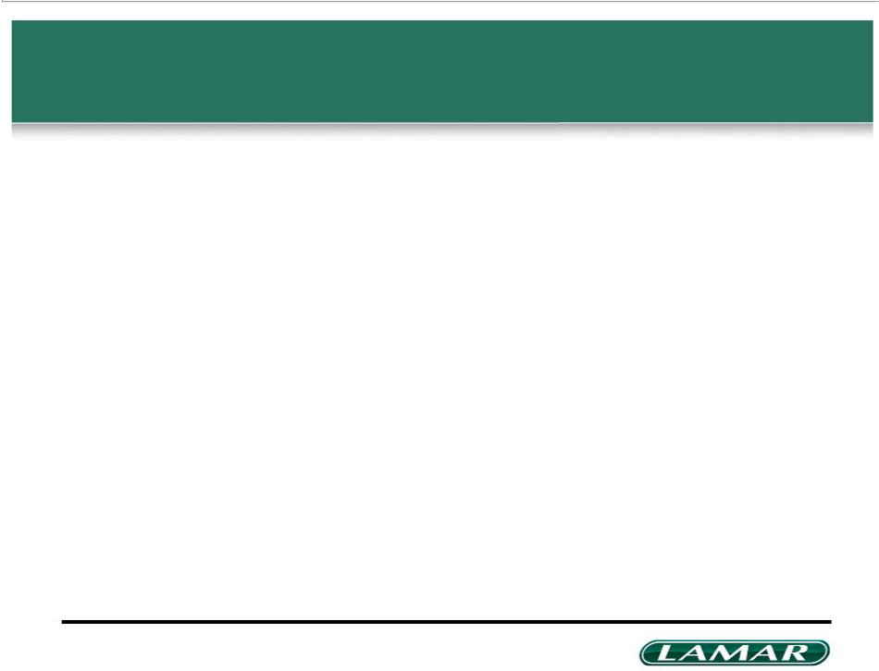
Disclaimer

Forward-looking Statements

This presentation contains forward-looking statements, including our financial guidance for 2014, the statements regarding our consideration of an election to real estate investment trust status; our ability to complete the REIT conversion effective for the taxable year beginning January 1, 2014; our intention to distribute accumulated earnings and profits to stockholders and make regular quarterly distributions to stockholders in 2014. These statements are subject to risks and uncertainties that could cause actual results to differ materially from those projected in these forward-looking statements. These risks and uncertainties include, among others: (1) that we may fail to qualify as a REIT effective for the taxable year beginning January 1, 2014 or at all, and, if we do qualify as a REIT, we may be unable to maintain that qualification (2) legislative, administrative, regulatory or other actions affecting REITs, including positions taken by the IRS; (3) our significant indebtedness; (4) the state of the economy and financial markets generally and the effect of the broader economy on the demand for advertising; (5) the continued popularity of outdoor advertising as an advertising medium; (6) our need for and ability to obtain additional funding for operations, debt refinancing or acquisitions; (7) the regulation of the outdoor advertising industry; (8) our ability to successfully implement our digital deployment strategy; and (9) the integration of any acquired companies and our ability to recognize cost savings or operating efficiencies as a result of these acquisitions. For additional information regarding factors that may cause actual results to differ materially from those indicated in our forward-looking statements, we refer you to the risk factors included in Item 1A of our Annual Report on Form 10-K for the year ended December 31, 2013. We caution investors not to place undue reliance on the forward-looking statements contained in this document. These statements speak only as of the date of this presentation, and we undertake no obligation to update or revise these statements, except as may be required by law.

Use of Non-GAAP Measures

Adjusted EBITDA, Funds From Operations, Adjusted Funds From Operations and Adjusted Funds From Operations Per Diluted Share are not measures of performance under accounting principles generally accepted in the United States of America (“GAAP”). These measures should not be considered alternatives to net income, cash flows provided by operating activities or other GAAP figures as indicators of the Company’s financial performance. Our management believes that Adjusted EBITDA, Funds From Operations, Adjusted Funds From Operations and Adjusted Funds From Operations Per Diluted Share are useful in evaluating the Company’s performance and provide investors and financial analysts a better understanding of the Company’s core operating results. Our presentations of these measures may not be comparable to similarly titled measures used by other companies. See the appendix, which provide reconciliations of each of these measures to the most directly comparable GAAP measure.

Additional Information

In connection with the proposed REIT conversion, we plan to effect a merger with and into a wholly owned subsidiary, which will be called Lamar Advertising REIT Company. We will

file a proxy statement to be used in connection with the stockholder vote on this merger. That proxy statement will be contained in a registration statement on Form S-4 to be filed by

Lamar Advertising REIT Company, and both companies will file other relevant documents concerning the proposed merger transaction with the Securities and Exchange Commission

(SEC). INVESTORS ARE URGED TO READ THE FORM S-4 AND PROXY STATEMENT (INCLUDING ALL AMENDMENTS AND SUPPLEMENTS THERETO) WHEN THEY BECOME AVAILABLE AND ANY OTHER RELEVANT DOCUMENTS FILED WITH THE SEC BECAUSE THEY WILL CONTAIN IMPORTANT INFORMATION ABOUT THE PROPOSED MERGER. You will be able to obtain documents free of charge at the website maintained by the SEC at www.sec.gov. In addition, you may obtain documents filed with the SEC by Lamar free of charge by contacting Secretary, 5321 Corporate Blvd., Baton Rouge, LA 70808.

We, our directors and executive officers and certain other members of management and employees may be deemed to be participants in the solicitation of proxies from our stockholders in connection with the merger. Information regarding the persons who may, under the rules of the SEC, be considered participants in the solicitation of proxies in connection with the merger will be included in the Form S-4 and proxy statement when they become available. Information about our directors and executive officers and their ownership of Lamar Advertising stock is set forth the proxy statement for our 2014 Annual Meeting of Stockholders, which was filed with the SEC on April 25, 2014. Investors may obtain additional information regarding the interest of such participants by reading the Form S-4 and proxy statement for the merger when they become available.

Investors should read the Form S-4 and proxy statement carefully when they become available before making any voting or investment decisions.

This communication does not constitute an offer to sell or the solicitation of an offer to buy any securities or a solicitation of any vote or approval.

2

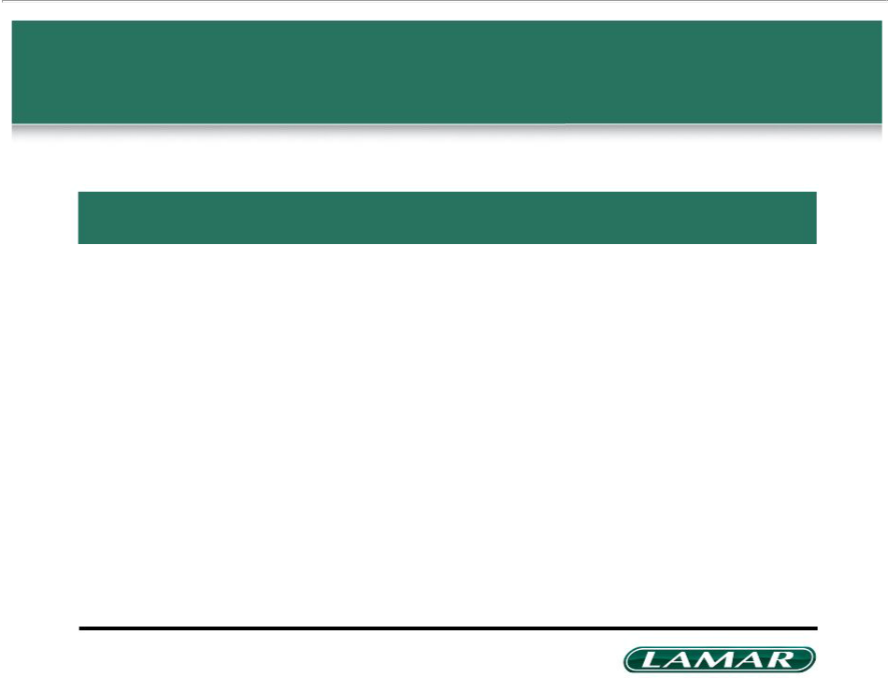
Agenda

Company background | 3
REIT conversion highlights | 22
Value creation and opportunities for growth | 26
Appendix | 29

3

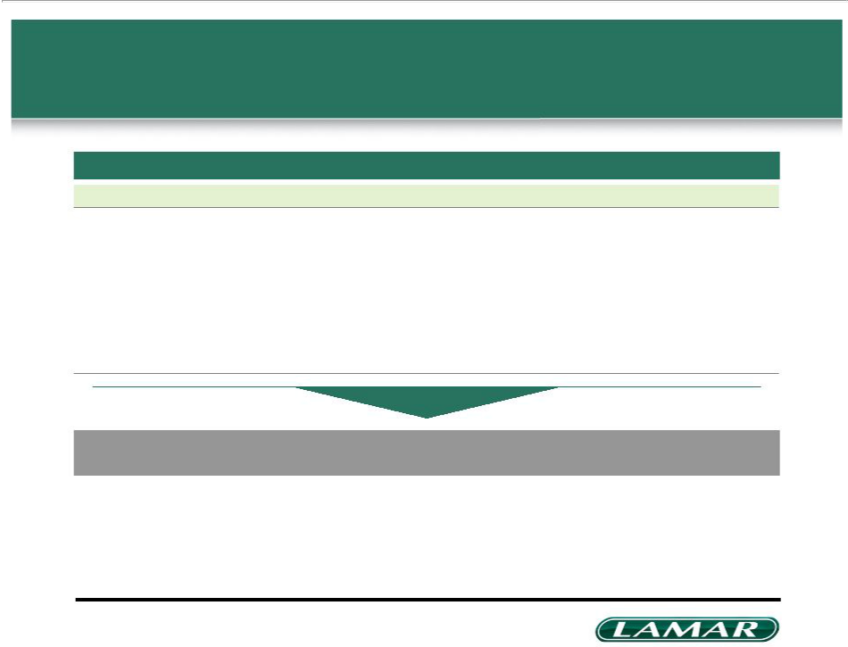
Introduction

Experienced management team

Name | Title | Years with Lamar
Kevin Reilly, Jr. | Chairman of the Board and President | 35
Sean Reilly | Chief Executive Officer | 23
Keith Istre | Chief Financial Officer and Treasurer | 35
Regional Managers (average years) |  | 31

Lamar’s management team has been with the company for an average of 31 years

4

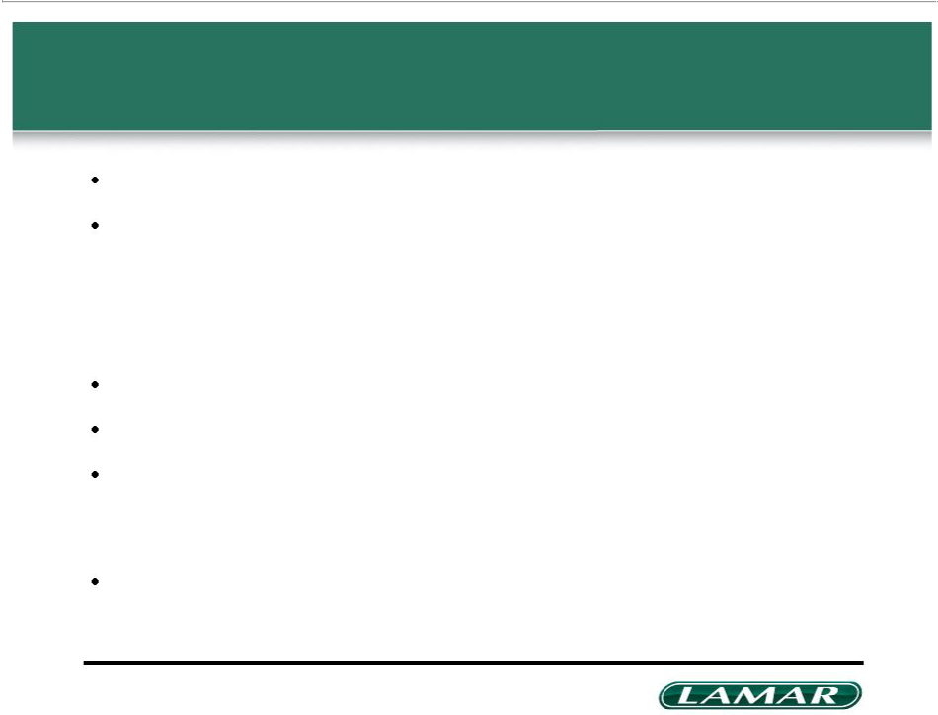
Company profile

Established in 1902 – over 110 years of operating experience

Largest outdoor advertising company in the US based on number of displays

– Operates approximately 145,000 billboard displays in 44 states, Canada and Puerto Rico

– Operates over 128,000 logo sign advertising displays in 23 states and Ontario, Canada

– Operates over 40,000 transit advertising displays in 16 states, Canada and Puerto Rico

Industry characterized by high barriers to entry due to permitting restrictions

Approximately 18% US market share – second behind Clear Channel Outdoor

78% of revenue generatedfrom less volatile local business, with diversified base of over

40,000 total billboard tenants

– Leading out of home provider in the vast majority of Lamar’s markets Approximately 825 local account executives across the US, Canada and Puerto Rico

5

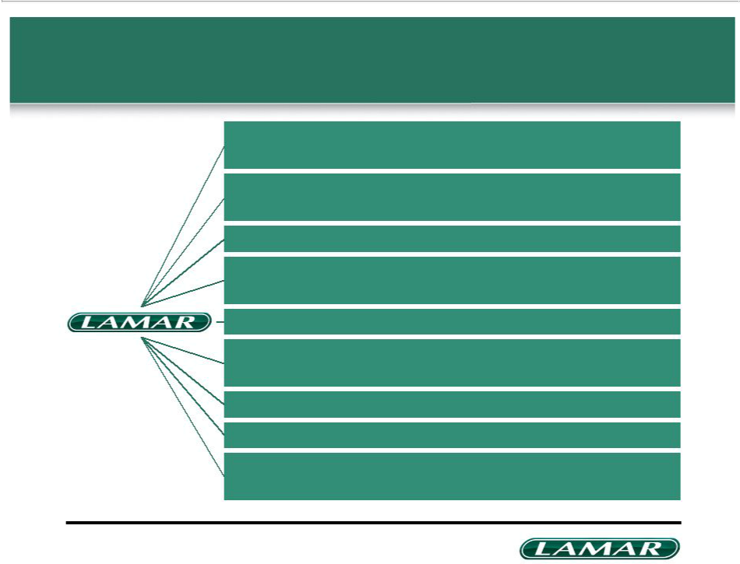
Key REIT investment considerations

Largest pure-play outdoor operator with expansive national footprint and over 145,000 billboard displays

Significant barriers to entry due to permitting restrictions which make real estate portfolio nearly impossible to replicate

Diversified base of 40,000+ tenants, none accounting for more than 1% of sales

Approximately 20% of billboard revenue is generated on Lamar-owned property, with balance divided among 60,000 lessors

OOH media effectively complements social & mobile advertising

Flexible business model allows Lamar to reduce maintenance capex to protect AFFO in economic downturns

Strong balance sheet with no near-term maturities; long & low fixed-rate profile

Potential to expand market share through AFFO-accretive acquisitions

Experienced, goal-oriented management team with disciplined approach to returning capital to shareholders

6

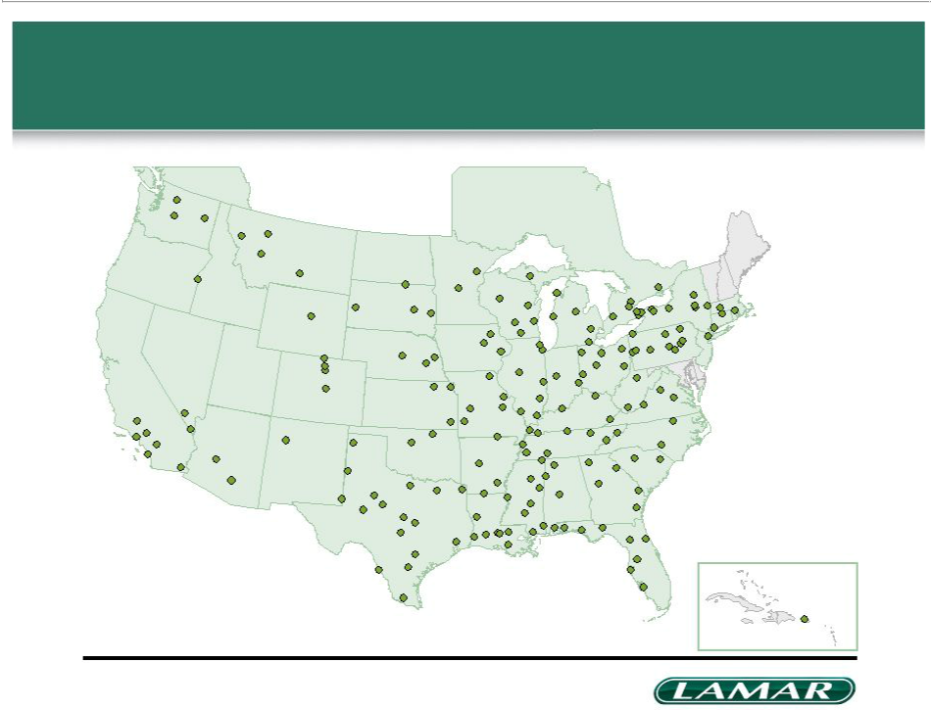
Expansive national footprint with approximately 145,000 billboards

Canada

7

Puerto Rico

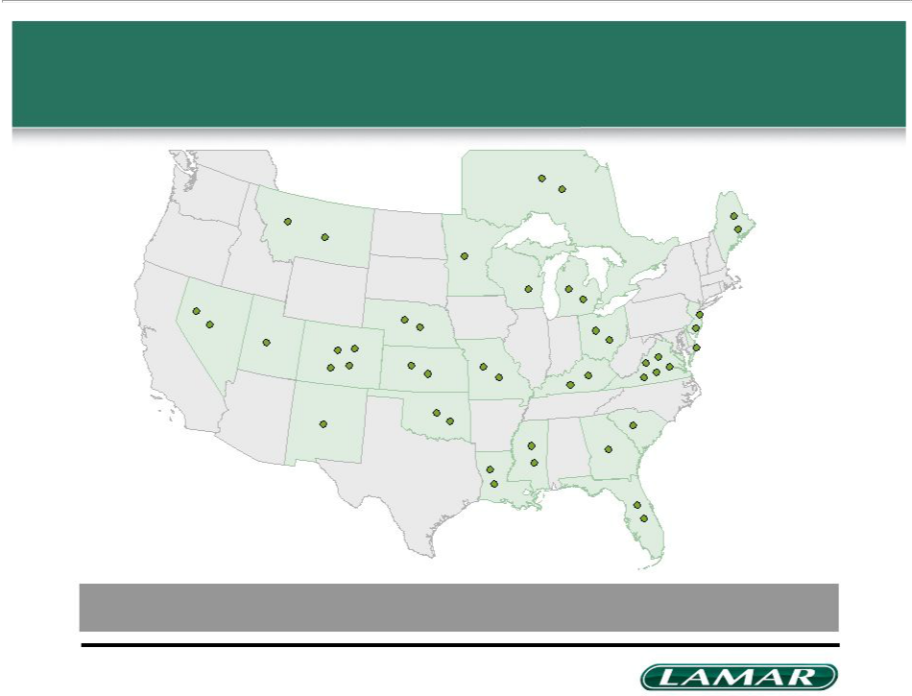
Largest provider of logo signs in the US

Operates nearly 89% of privatized state logo contracts covering over 128,000 displays

8

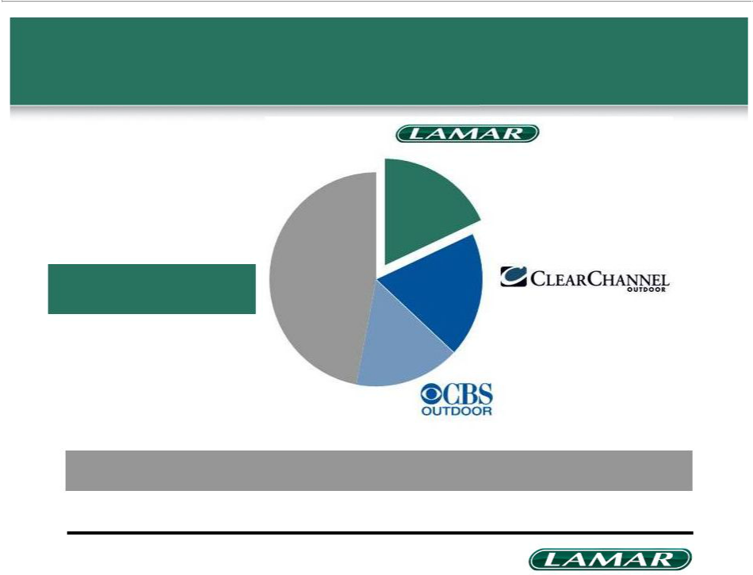
Lamar maintains a leading share of the U.S. outdoor advertising market

Other | 18%
47%

~$2bn in high-quality,
REIT-eligible billboard assets

19%

16%

Potential acquisitions could expand market share and increase AFFO

Source: Company filings; Outdoor Advertising Association of America
Note: Market share based on Lamar, CBS Outdoor and Clear Channel Outdoor domestic revenue as a percentage of 2013 out of home media spending

9

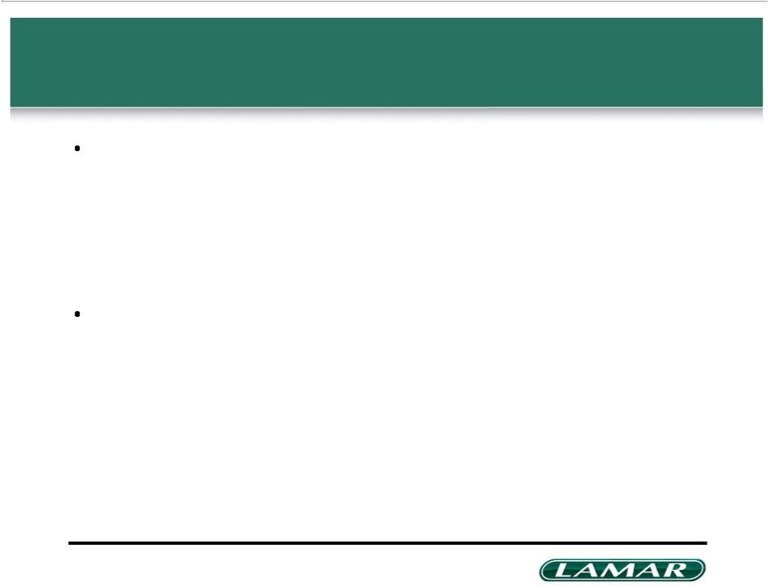
Out-of-home regulations provide high barriers to entry

Lamar typically owns permits that allow OOH advertising at each location

– Control of permit protects current inventory and prevents encroachment from other players in local and national markets

– Permits are the most valuable assets typically obtained in an acquisition

– Lamar's permits have been collected over the course of its 110+ year history

Federal, state and local regulations help Lamar maintain leading share within its markets and provide high barriers to entry for new entrants

– Rules govern where and how billboards may be built (i.e. typically cannot build new billboard within a certain distance of existing structures)

– Many existing structures have been grandfathered in and cannot be rebuilt by another operator without obtaining zoning variance

10

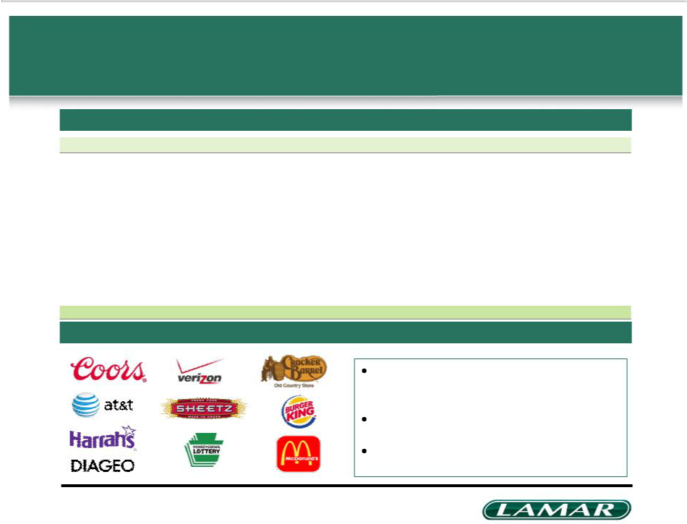
No advertising tenant accounts for more than 1% of total revenue

Net advertising revenue breakdown

 | FY 2007 | FY 2008 | FY 2009 | FY 2010 | FY 2011 | FY 2012 | FY 2013
Restaurants | 10% | 10% | 12% | 12% | 13% | 13% | 13%
Retailers | 10% | 11% | 10% | 10% | 10% | 11% | 11%
Healthcare | 7% | 7% | 8% | 9% | 9% | 10% | 10%
Service | 6% | 6% | 7% | 8% | 8% | 8% | 9%
Amusement | 5% | 5% | 6% | 6% | 7% | 7% | 7%
Automotive | 9% | 7% | 6% | 6% | 6% | 6% | 7%
Gaming | 6% | 6% | 7% | 6% | 6% | 6% | 5%
Financial | – | – | 5% | 5% | 5% | 5% | 4%
Telecom | 5% | 5% | 4% | 5% | 5% | 4% | 3%
Hotels & Motels | 5% | 5% | 5% | 4% | – | – | 3%
Education | – | – | – | – | 4% | 4% | –
Real Estate | 9% | 6% | – | – | – | – | –
Total | 72% | 68% | 70% | 71% | 73% | 74% | 72%

Top 10 tenants (2013)

Long-standing relationships with many of our

tenants

Contracts range from 30 days to 1 year

“One-stop-shopping” capabilities with billboard

and transit products

11

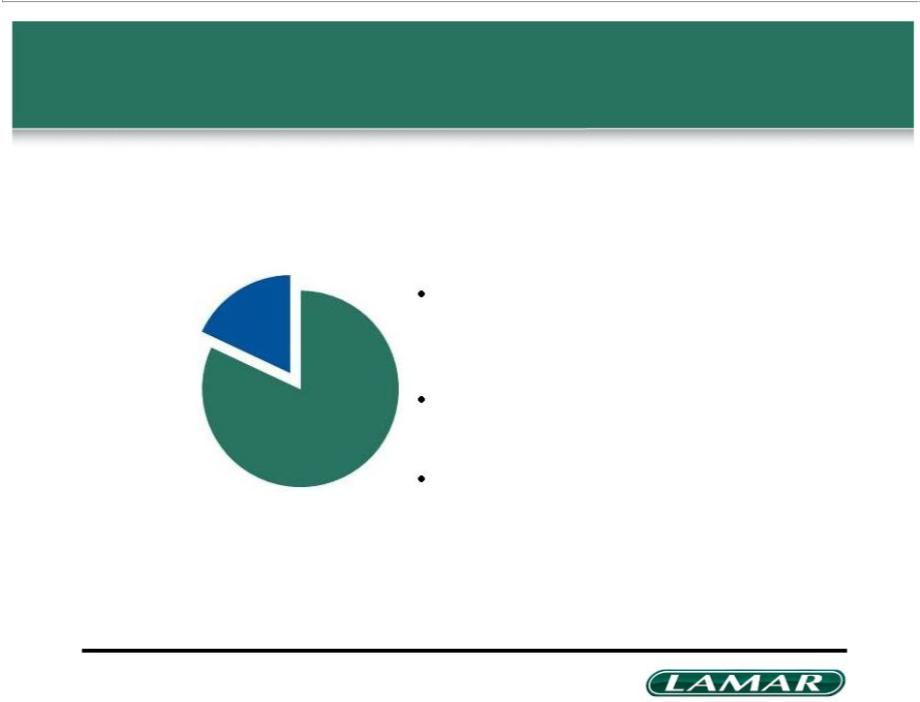
Diversified underlying real-estate portfolio

18% of billboard revenue generated on structures on Lamar-owned property

82% of billboard revenue from structures on property leased from 60,000 lessors

Lamar has opportunistically purchased easements beneath key locations, including many digital structures

Diversification and regulatory regime help preserve footprint and limit inflation in lease expense

Lamar owns approximately 10% of its billboard locations

12

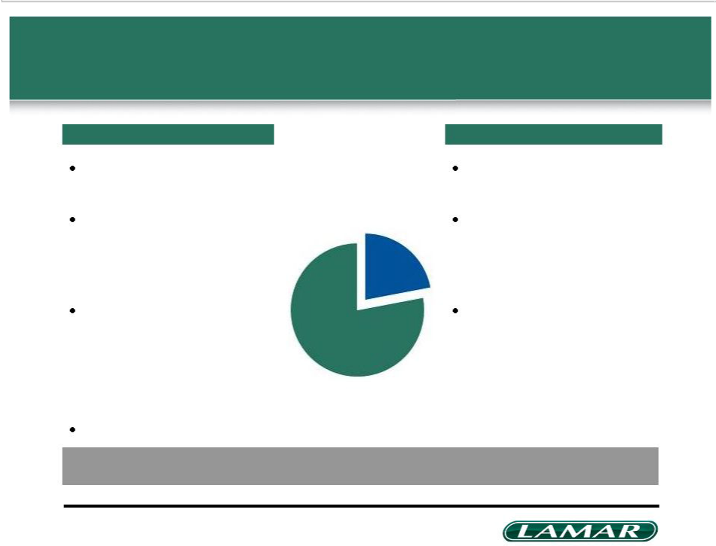
Focus on local advertising spending differentiates Lamar

Local focus
Local demand less influenced
by economic swings
Large on-the-ground sales
force cultivates strong
relationships with local
decision makers and retailers
Lamar’s local revenue
generation compares favorably
to industry’s
– Clear share leader in vast | Local
majority of our markets | Local
majority of our markets | 78%
Yields optimized at local levels

National

22%

National performance

Diversified, blue chip customer base

Fifty member sales team across nine cities manages relationships with OOH agencies and large customers

Recent acquisitions and greenfield development have bolstered presence in key markets such as Phoenix, Boston and Philadelphia

Lamar is the leading out of home provider in the vast majority of its markets

Note: As of December 31, 2013

13

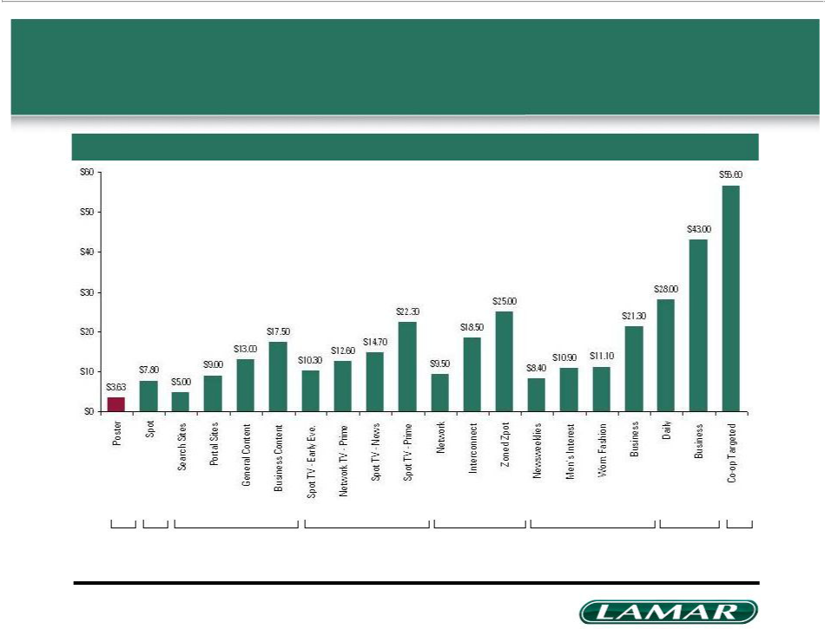
Outdoor remains a low cost, wide reaching advertising medium

Relative average cost to reach 1,000 adults between ages 25 and 54 (CPM)

OOH Radio Online Broadcast TV Cable TV Magazines Newspapers Direct Mail

Source: Outdoor Advertising Association of America

14

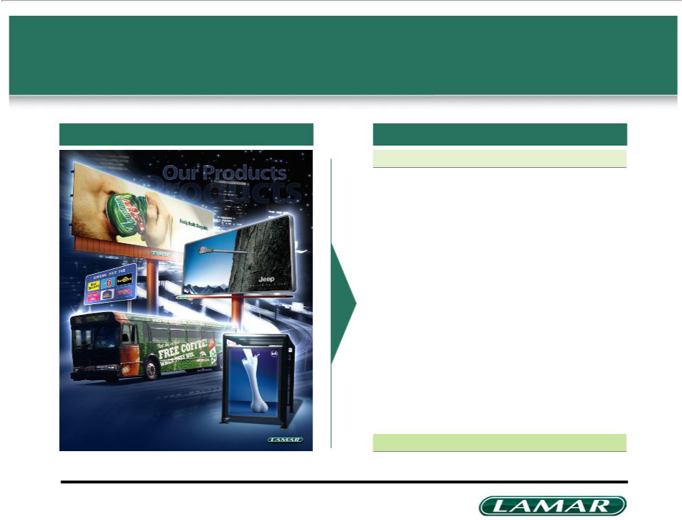
Diverse product mix across digital and analog assets

Company profile | Revenue contribution FYE 2013
 |  | ($mm) | (%)
 | Analog bulletin displays | $657 | 53%
 | Analog poster displays | 263 | 21%
 | Digital posters & bulletins | 184 | 15%
 | Transit displays | 75 | 6%
 | Logos | 67 | 5%
 | Total | $1,246 | 100%
 | 15

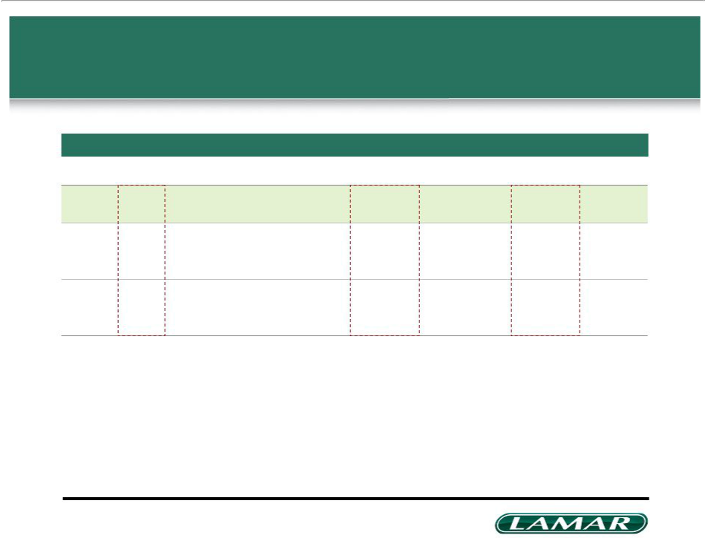
Historically, Lamar has emerged strongly from economic downturns

Annual pro forma financials

 | Economic downturn |  |  |  |  |  |  |  |  |  | Economic downturn |  |  |  |  |  |  | Economic downturn
 |  | 1991 | 1992 | 1993 | 1994 | 1995 | 1996 | 1997 | 1998 | 1999 | 2000 | 2001 | 2002 | 2003 | 2004 | 2005 | 2006 | 2007 | 2008 | 2009 | 2010 | 2011 | 2012 | 2013
Y/Y net |  | 1% (2)% |  | 4% | 11% | 9% | 7% | 7% | 8% | 6% | 9% | (2)% | 2% | 2% | 7% | 7% | 8% | 7% | (3)%(13)% |  | 3% | 3% | 3% | 2%
revenue
growth¹
Adj. EBITDA |  | 32% | 31% | 35% | 37% | 40% | 41% | 46% | 47% | 47% | 48% | 45% | 43% | 43% | 45% | 45% | 44% | 46% | 43% | 42% | 43% | 43% | 43% | 44%
margin

- Represents organic growth of the Company adjusted for acquisitions; Pro forma net revenue includes adjustments to the comparable periods to include the effect of any acquisitions or divestitures

16

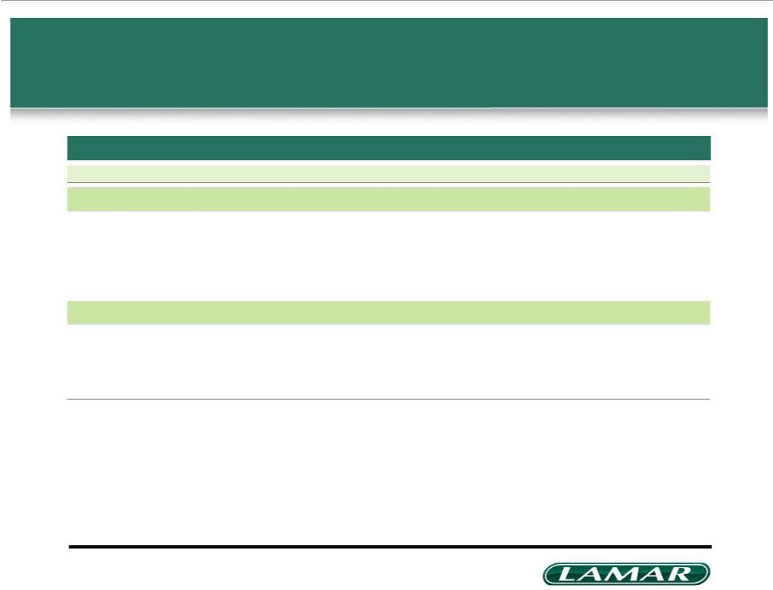
Historical financial information

Lamar Advertising Co. ($mm)

 | FY 2007 | FY 2008 | FY 2009 | FY 2010 | FY 2011 | FY 2012 | FY 2013
Net revenues | $1,209.6 | $1,198.4 | $1,055.1 | $1,094.1 | $1,130.7 | $1,179.7 | $1,245.8
% growth | 8.0% | (0.9%) | (12.0%) | 3.7% | 3.3% | 4.3% | 5.6%
Operating expenses¹ | 653.7 | 686.3 | 614.7 | 627.1 | 646.4 | 668.4 | 700.7
% of net revenues | 54.0% | 57.3% | 58.3% | 57.3% | 57.2% | 56.7% | 56.2%
2 | $555.9 | $512.1 | $440.5 | $467.0 | $484.3 | $511.3 | $545.1
Adjusted EBITDA
% of net revenues | 46.0% | 42.7% | 41.7% | 42.7% | 42.8% | 43.3% | 43.8%
Capital expenditures | 220.5 | 198.1 | 38.8 | 43.5 | 107.1 | 105.6 | 105.7
% of net revenues | 18.2% | 16.5% | 3.7% | 4.0% | 9.5% | 9.0% | 8.5%

¹ Excludes non-cash compensation
- Adjusted EBITDA is defined as earnings (loss) before non-cash compensation, interest, taxes, depreciation, amortization, gain or loss on disposition of assets and investments and loss on debt extinguishment. Refer to the appendix for a reconciliation of Adjusted EBITDA to Net Income (Loss)

17

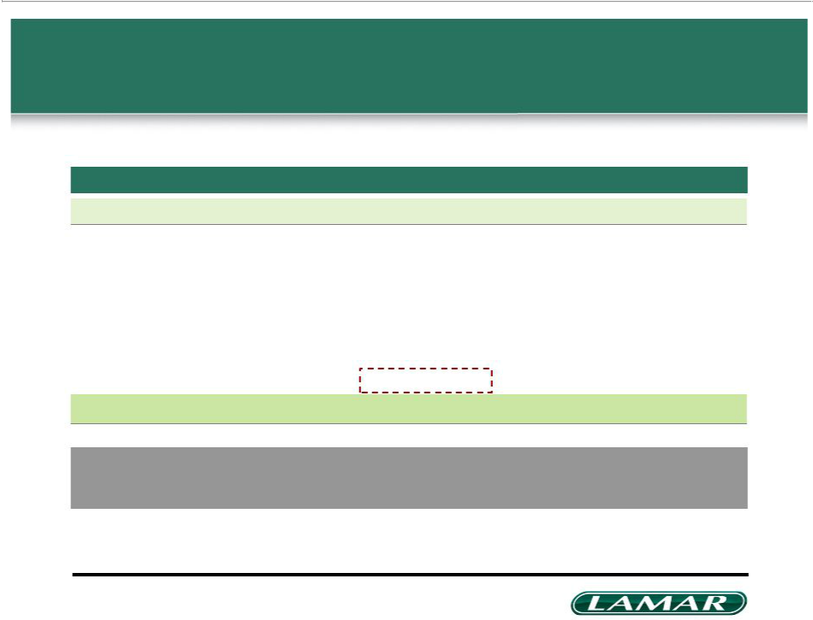
Lamar is a strong free cash flow generator

Lamar Advertising Co. ($mm)

 | FY 2007 | FY 2008 | FY 2009 | FY 2010 | FY 2011 | FY 2012 | FY 2013
Adjusted EBITDA¹ | $555.9 | $512.1 | $440.5 | $467.0 | $484.3 | $511.3 | $545.1
Less:
Interest expense, net | 155.3 | 153.0 | 177.1 | 168.7 | 152.0 | 139.0 | 131.4
Current tax expense (benefit) | 31.0 | (10.7) | (16.0) | 1.1 | 2.8 | 1.9 | 4.0
Preferred dividends | 0.4 | 0.4 | 0.4 | 0.4 | 0.4 | 0.4 | 0.4
Capital expenditures | 220.5 | 198.1 | 38.8 | 43.5 | 107.1 | 105.6 | 105.7
Free cash flow | $148.7 | $171.3 | $240.2 | $253.3 | $222.0 | $264.4 | $303.6

Lamar has the ability to reduce maintenance capex,

allowing it to protect AFFO even in difficult economic cycles

- Adjusted EBITDA is defined as earnings (loss) before non-cash compensation, interest, taxes, depreciation, amortization, gain or loss on disposition of assets and investments and loss on debt extinguishment. Refer to the appendix for a reconciliation of adjusted EBITDA to net income (loss)

18

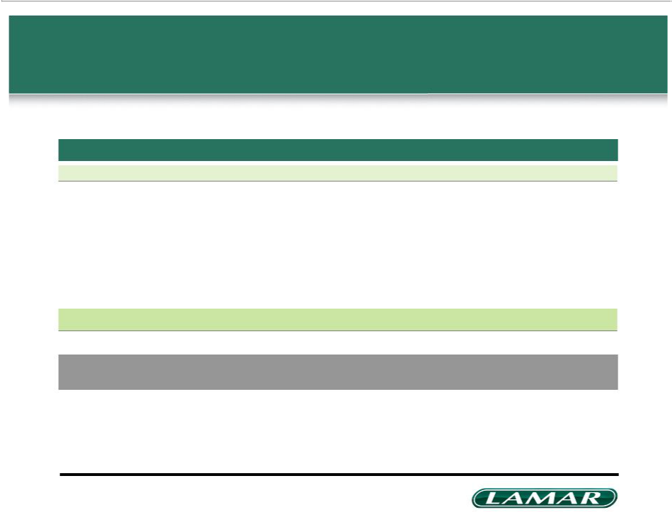
Capital expenditures overview

$mm

 | FY 2007 | FY 2008 | FY 2009 | FY 2010 | FY 2011 | FY 2012 | FY 2013
Billboards–Traditional | 68.7 | 58.1 | 7.4 | 9.5 | 34.5 | 29.1 | 21.3
Billboards–Digital | 92.1 | 103.7 | 15.2 | 13.2 | 41.3 | 42.1 | 50.2
Logos | 10.2 | 7.6 | 5.3 | 8.5 | 10.1 | 8.7 | 11.2
Transit | 2.0 | 1.0 | 5.4 | 0.9 | 0.8 | 0.3 | 0.2
Land and buildings | 31.4 | 11.2 | 0.6 | 2.5 | 4.5 | 12.8 | 9.5
Other PP&E | 16.1 | 16.5 | 4.9 | 8.9 | 15.9 | 12.6 | 13.3
Total capex | 220.5 | 198.1 | 38.8 | 43.5 | 107.1 | 105.6 | 105.7

FY 2014: ~$100mm consisting of ~$45mm growth and ~$55mm maintenance capital expenditures

19

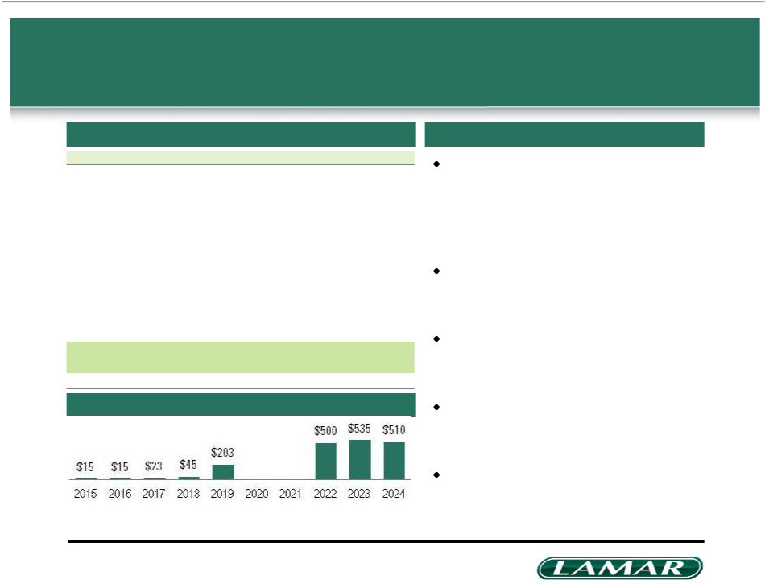
Strong balance sheet with no near term maturities

$mm

As of March 31, 2014 | Amount¹ | xEBITDA
Cash | $28.4
$400mm Revolving credit facility | 80.0
New Term Loan A | 300.0
Total secured debt | $380.0 | 0.7x
5.375% senior notes due 2024 | 510.0
Total senior debt | $890.0 | 1.6x
5.000% senior sub notes due 2023 | 535.0
5.875% senior sub notes due 2022 | 500.0
Other debt | 1.8
Total debt | $1,926.8 | 3.5x
Net debt | $1,898.4 | 3.5x
LTM 3/31/14 Adjusted EBITDA | $546.4
Memo: Interest coverage ratio |  | 3.9x

Capital structure highlights

Redeemed $400mm 2018 subordinated notes in April 2014 with $300mm new term debt, revolving credit borrowings and cash on hand

Lamar maintains modest leverage ratios post-conversion

Very strong interest and fixed charge coverage ratios

Maturity profile ($mm) | Simple and transparent capital
 | structure

Annual dividends expected to be paid

out of internally-generated cash flow

- Balances shown are pro forma for the borrowing of $300mm under our Term Loan A and $80mm under our revolving credit facility in April 2014, which was used to fund the redemption of the $400mm Senior Subordinated Notes on April 21, 2014

20

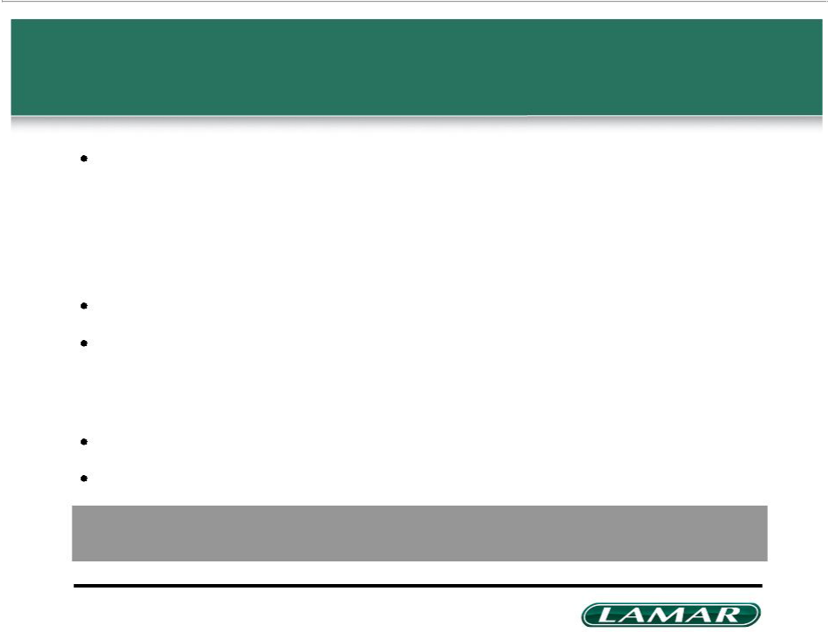
Key business initiatives

Focus on financial discipline and capital allocation

– Limited strategic acquisition activity

– Continue to use free cash flow to reduce debt

– Continue to invest in highly profitable digital billboards No approved stock buyback plan
Focus on cost containment

– No near term plans to increase headcount; headcount in 2008 was 3,500+ and currently stands at approximately 3,000

Focus on improving pricing and occupancy statistics Expect to elect REIT status effective January 1, 2014

Through numerous initiatives, Lamar has demonstrated its prudent financial strategy, generated free cash flow and is well positioned as the economy accelerates

21

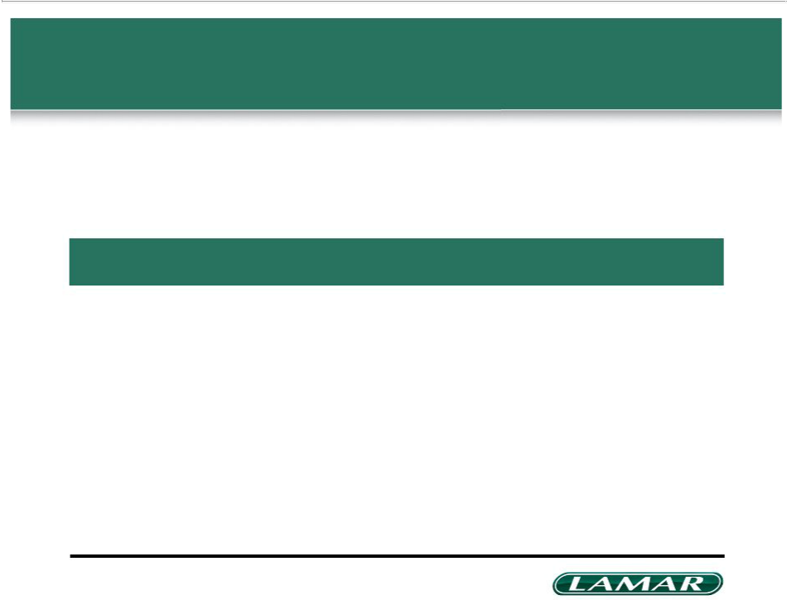
Agenda

Company background | 3
REIT conversion highlights | 22
Value creation and opportunities for growth | 26
Appendix | 29

22

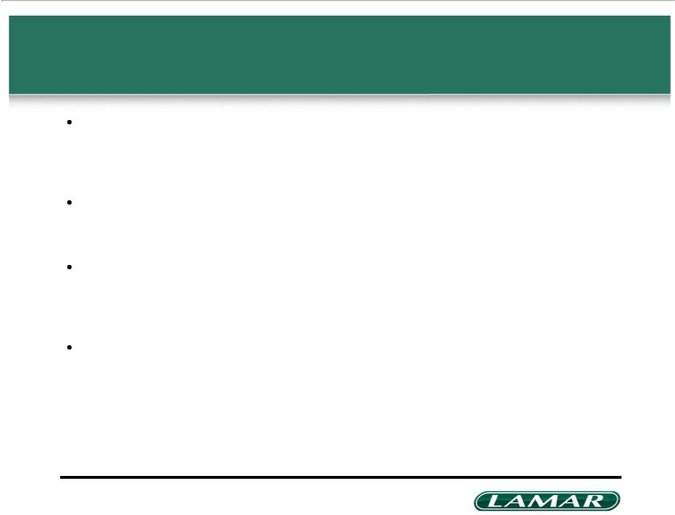
REIT conversion highlights

Favorable IRS PLR received, final Board authorization expected

– Expect to complete a merger of Lamar into a newly formed, wholly owned subsidiary to adopt a new REIT-compliant charter

– Merger will be subject to stockholder approval

Lamar REIT structural reorganization complete

– Expect to elect REIT status effective January 1, 2014

– No impact on customer service; No asset divestitures; No business disruption

Composition of qualified REIT subsidiary (QRS) and taxable REIT subsidiary (TRS)

– TRS comprised of transit advertising business, design, production & installation services and foreign operations in Canada and Puerto Rico; we expect the tax leakage to be approximately $15mm in 2014

– QRS comprised of billboard and logo sign assets

Significant increase in shareholder value

– Higher net income

– Dividends initiated in connection with expected conversion

– Potential to expand investor base and valuation multiples

– Continued strong access to capital at attractive rates; modest post conversion leverage: ~3.5x o Provides dry powder for future accretive acquisitions

23

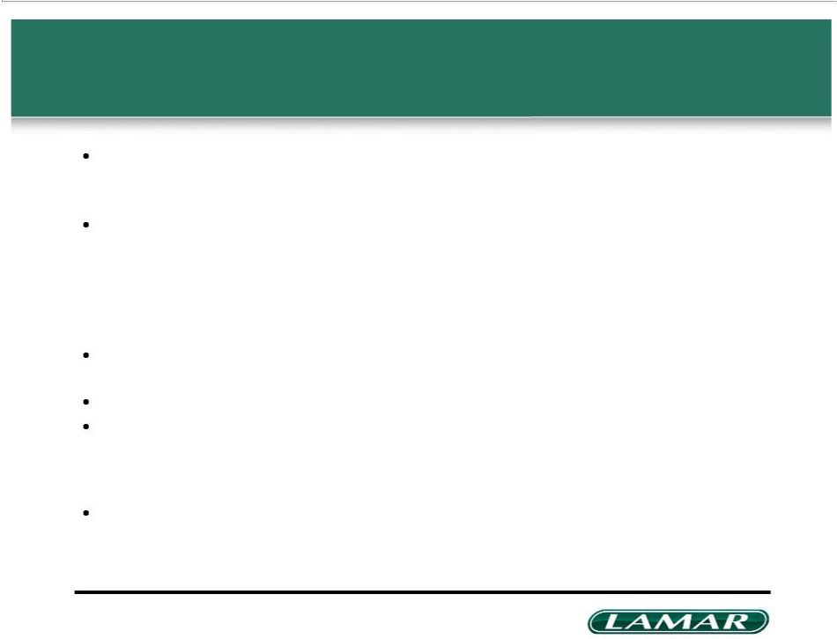
REIT conversion highlights (cont’d)

Non-REIT E&P dividend

– Accumulated non-REIT E&P: ~$40mm

– Plan to distribute in cash along with three regular quarterly distributions to stockholders during 2014

2014 financial guidance

– Projected earnings per diluted share: $2.81 to $2.91¹

– Projected Adjusted Funds from Operations (AFFO) per diluted share: $4.03 to $4.13²

– 2014 expected annual dividend per share (includes non-REIT E&P distribution of $40mm): $2.50³ o Announced on May 22, 2014 a cash dividend of $0.83 per share to be paid on June 30, 2014 to

shareholders of record on June 1, 2014

2014 capital expenditures

– ~$100mm consisting of ~$45mm growth and ~$55mm maintenance capital expenditures

Targeting annual dividend equal to ~60% of AFFO per diluted share in 2014 Refinancing transaction

– On April 21, 2014, Lamar Media Corp. redeemed its outstanding $400mm 7 7/8% Senior Subordinated Notes due 2018 at 103.938% principal

– Funded repayment with $300mm new term debt, revolving credit borrowings and cash

Estimated total REIT one-time conversion costs of ~$5mm

¹ Calculated before dividends

- See “Reconciliation to AFFO per diluted share” in Appendix ³ Subject to declaration by Board of Directors

24

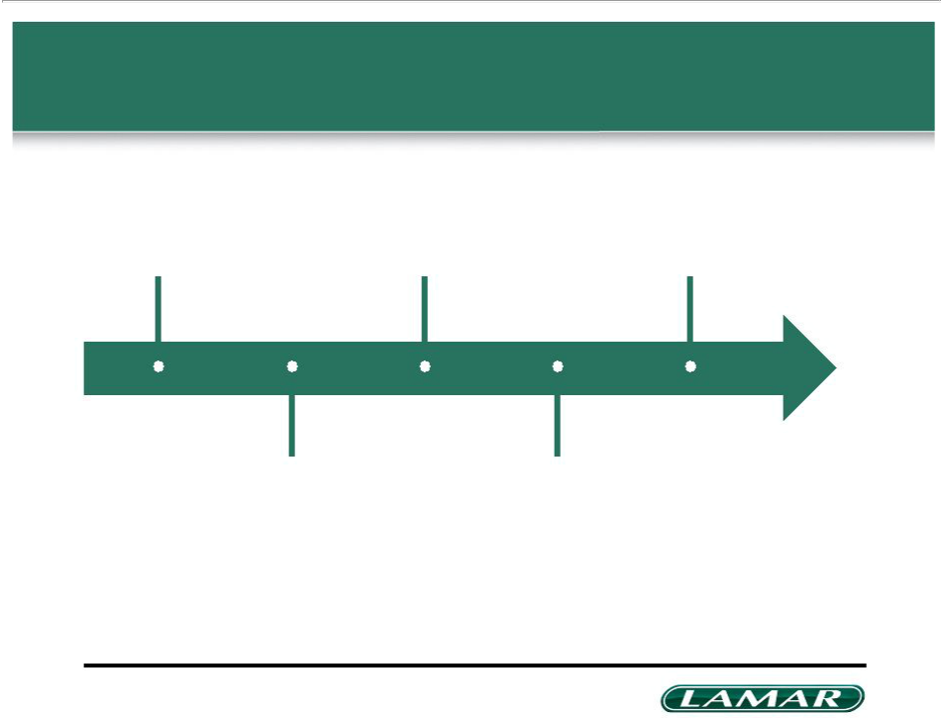
Indicative timeline for 2014 Distributions

May 22, 2014 | June 30, 2014 | End December 2014
Cash dividend | Quarterly dividend | Quarterly cash dividend
announced | to be paid ($0.83) | expected to be paid

June 1, 2014

Record date for June 30

quarterly dividend

End September 2014

Quarterly cash dividend

expected to be paid

25

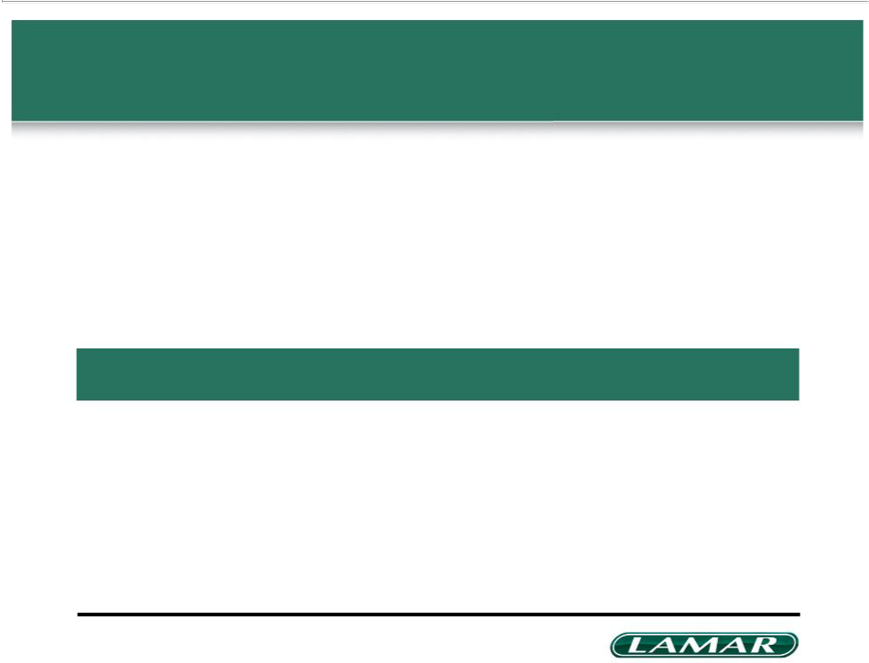
Agenda

Company background | 3
REIT conversion highlights | 22
Value creation and opportunities for growth | 26
Appendix | 29

26

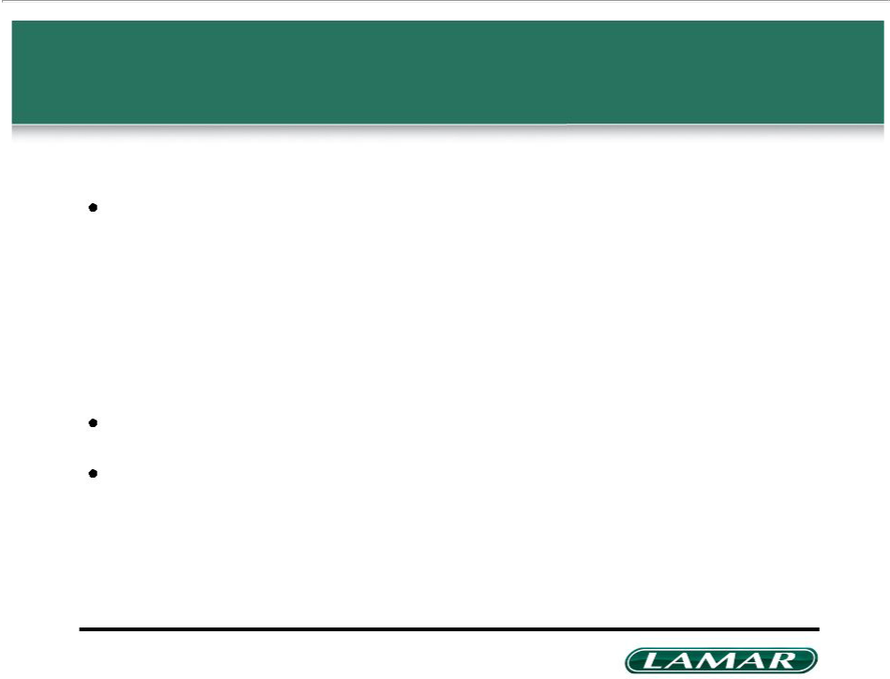
Significant opportunities for earnings growth and value creation

Organic growth potential without the need to raise new capital

– Continued investment in ROI efficient digital displays in new and existing markets to drive revenue growth

– Rate and occupancy increases driven by focused local and national sales force and acceleration in GDP growth

Ability to use free cash flow to reduce debt and interest expense Additional growth opportunities through select M&A investment

27

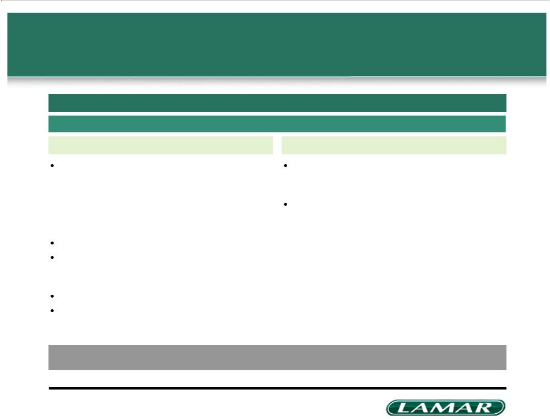
Lamar’s capital allocation policy

Maintain ample liquidity and solid balance sheet

Target ~3.5x Leverage

AFFO for dividend AFFO available for future growth

Expected 2014 dividends of $2.50 per share¹

– $0.83 dividend declared, payable June 30, 2014 to shareholders of record on June 1, 2014

– Additional distributions expected at end of September and end of December 2014

– Reflects annualized 2014 dividend of $0.625 per quarter Expect to pay dividends at the end of each quarter in 2015

Distribute 100% of net taxable income once NOLs are exhausted

– Paid out of internally generated cash flow Revisit payout ratio annually or sooner if required Increase dividend with future growth and utilization of NOLs

Invest in display acquisitions and development to grow earnings

– Opportunistic M&A

Unused amounts available for increased dividends and / or debt reduction

2014 AFFO Guidance : $4.03 to $4.13 per diluted share

¹ Subject to declaration by Board of Directors

28

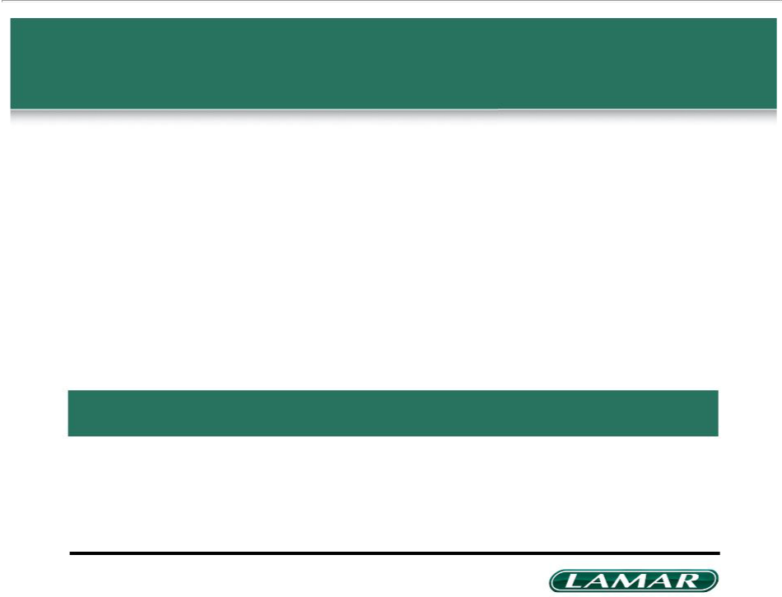
Agenda

Company background | 3
REIT conversion highlights | 22
Value creation and opportunities for growth | 26
Appendix | 29

29

Summary historical financials

Adjusted EBITDA reconciliation (Lamar AdvertisingCo.) ($mm)

Adjusted EBITDA ¹

Non-cash compensation

Depreciation and amortization

Gain on disposition of assets/investments

Interest expense, net

(Gain) loss on debt extinguishment

Loss from other-than-temporary impairment of investment

 |  |  |  |  |  |  | For the three
 |  |  |  |  |  |  | months ended
 |  |  |  |  |  |  | March 31, |  | LTM
FY 2007 | FY 2008 | FY 2009 | FY 2010 | FY 2011 | FY 2012 | FY 2013 | 2013 | 2014 | Q1 2014
$555.9 | $512.1 | $440.5 | $467.0 | $484.3 | $511.3 | $545.1 | $103.1 | $104.4 | $546.4
27.5 | 9.0 | 12.5 | 17.8 | 11.7 | 14.5 | 25.0 | 10.8 | 3.9 | 18.1
306.9 | 331.7 | 336.7 | 312.7 | 299.6 | 296.1 | 300.6 | 73.9 | 69.5 | 296.2
(19.4) | (9.2) | (6.9) | (4.9) | (10.5) | (13.8) | (3.8) | (0.6) | (0.2) | (3.4)
166.0 | 169.1 | 196.5 | 185.7 | 170.5 | 156.8 | 146.1 | 36.7 | 30.2 | 139.6
– | – | (3.3) | 17.4 | 0.7 | 41.6 | 14.3 | – | 5.2 | 19.5
– | – | – | – | – | – | – | – | 4.1 | 4.1

Income tax expense | 33.9 | 9.3 | (36.4) | (22.7) | 5.4 | 8.2 | 22.8 | (7.4) | (3.5) | 26.7
(benefit)
Net income (loss) | $41.0 | $2.2 | $(58.6) | $(39.0) | $6.9 | $7.9 | $40.1 | $(10.3) | $(4.8) | $45.6

- Adjusted EBITDA is defined as earnings (loss) before non-cash compensation, interest, taxes, depreciation, amortization, gain or loss on disposition of assets and investments and loss on debt extinguishment

30

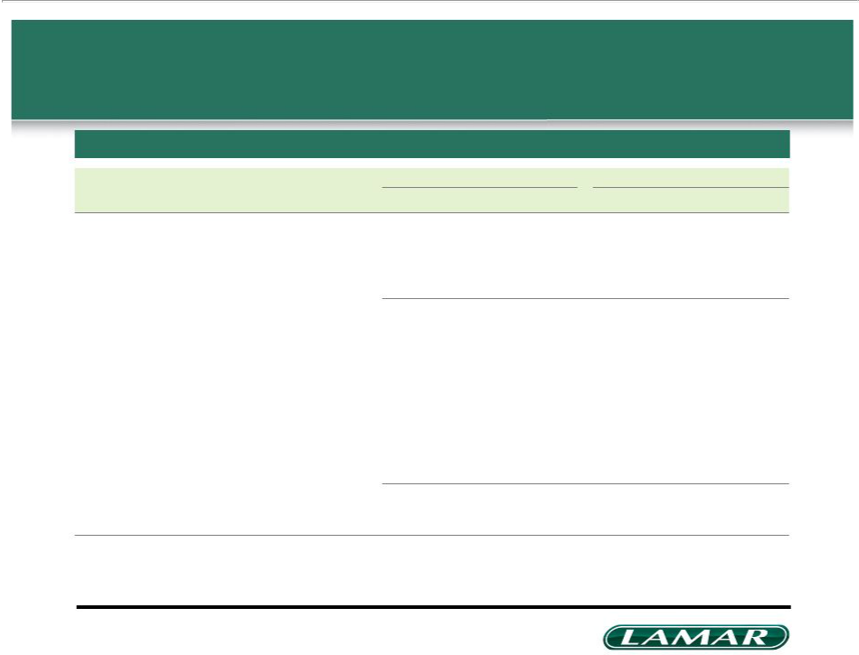
Reconciliation to AFFO per diluted share

$mm

 | For the three months ended March 31, |  | For the year ended December 31, 2014
 |  |  | Low end of | High end of
 | 2013¹ | 2014¹ | guidance | guidance
Net income (loss) | $(10.3) | $(4.8) | $268.7 | $278.3
Real estate related depreciation and amortization | 69.9 | 65.2 | 230.5 | 230.5
(Gain) losses from real estate | (0.5) | – | (4.0) | (4.0)
Adjustment for non-controlling interest | 0.2 | – | 1.0 | 1.0
Adjustment to eliminate non-cash tax effect of conversion | – | – | (119.0) | (119.0)
Funds From Operations ("FFO")¹ | $59.3 | $60.4 | $377.2 | $386.8
Straight line-revenue | – | – | 1.3 | 1.3
Straight-line expense | (0.1) | – | 1.2 | 1.2
Stock-based compensation expense | 10.8 | 3.9 | 24.4 | 24.4
Non-cash tax expense (benefit) | (7.8) | (5.5) | – | –
Non-real estate related depreciation and amortization | 4.0 | 4.3 | 12.1 | 12.1
Amortization of deferred financing and debt issuance costs | 2.9 | 1.3 | 4.4 | 4.4
Loss on debt extinguishment | – | 5.2 | 20.8 | 20.8
Loss from other-than-temporary impairment of investment | – | 4.1 | – | –
Capitalized expendituresmaintenance– | (18.7) | (14.9) | (55.0) | (55.0)
Adjustment for non-controlling interest | (0.2) | – | (1.0) | (1.0)
Adjusted Funds From Operations ("AFFO")¹ | $50.2 | $58.8 | $385.4 | $395.0
Divided by weighted average diluted shares outstanding | 94.4 | 95.4 | 95.7 | 95.7
AFFO per diluted share | $0.53 | $0.62 | $4.03 | $4.13

- The calculation of FFO is based on the definition as set forth by the National Association of Real Estate Investment Trusts (NAREIT); a reconciliation of net income (loss) to FFO and the calculation of AFFO are also presented above; FFO and AFFO, which are non-GAAP financial measures, may not be comparable to those reported by REITs that do not compute these measures in accordance with NAREIT definitions, or that interpret those definitions differently than we do; our net loss for the three months ended March 31, 2014 reflects our current status as a regular domestic C Corporation for U.S. Federal Income Tax purposes; if we elect to qualify and elect to be taxed as a REIT, our tax expense would be lower than our historical effective tax rates

31

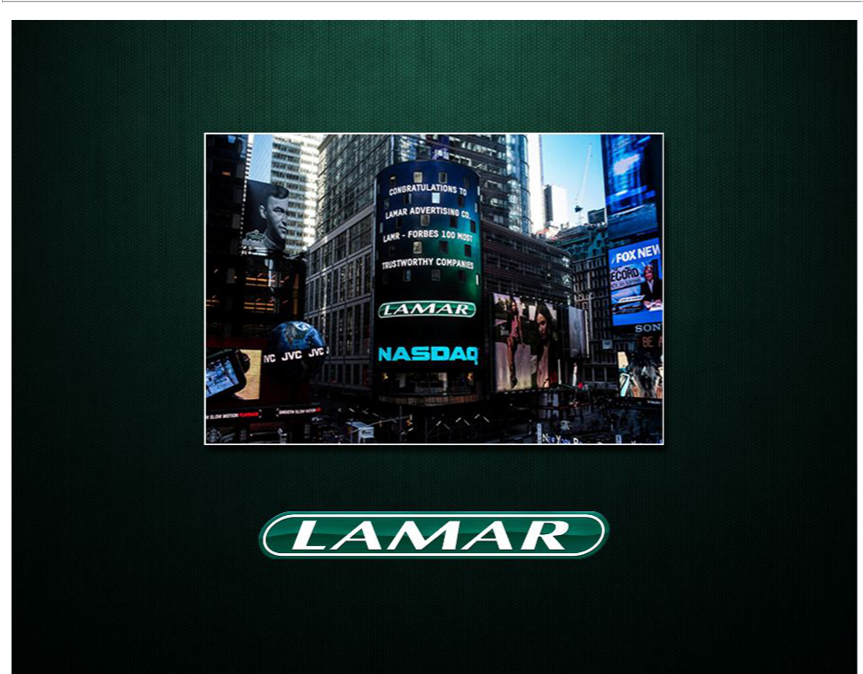

32

